 | PEAK SCHOOL  Year 1/2: Helping your child with their understanding of number | 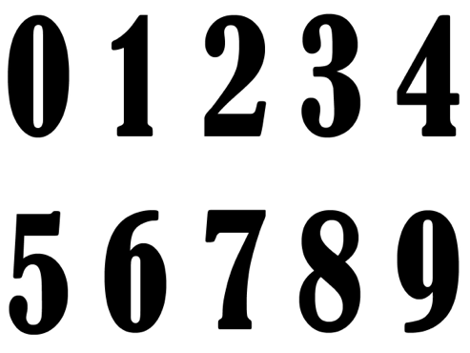

Key skills and how to support them:

- Accurate counting of objects. Take any opportunity to count objects. Throw a dice and ask your child to pick up that number of Lego bricks.
- Counting forwards and backwards first in ones and then in groups of 2’s, 5’s and 10’s. This is a really simple skill to help your child with and can be done anywhere – in the car, before bed at night… Remember little and often is best. Count with your child or say alternate numbers, sing rhymes that involve numbers. Play games that involve counting forwards and backwards like Snakes and Ladders. Ask questions such as ‘What number comes after 5?’ What is one less than 10?”
- Ordering numbers. ‘Which is bigger – 12 or 20?’ How do you know? ‘Can you think of a number that comes between 40 and 60?’ Look at numbers on the 100 square and draw attention to how the numbers are written 34 is 3 ten and 4 ones not the same as 43. Use straws to make bundles of tens and use these to show what 3 tens looks like and how it is different from 3 single straws. Show the value of tens and ones using a Place Value board.
- Addition and subtraction facts to 10 and 20. Focus on memorising pairs of numbers that total 10 and then 20. Use dominoes, dice or playing cards to add interest to basic addition or take away activities.

Useful Resources:

Dominoes, Dice, Playing cards, Games involving number tracks, 100 squares,
Place Value board, Straws.

