Peak School
PARENT SURVEY RESULTS FROM JUNE 2013

I am aware that the school has recently reviewed its Mission statement and created a new strap line (Above and Beyond). Agree/Strongly Agree = 80% and 8% don’t know

I feel I have a better understanding of PYP and inquiry learning at Peak School now than I did at the start of the year?
Agree/Strongly Agree = 84% and 8% don’t know

The school supports my child’s personal, social and physical development.
Agree/Strongly Agree = 88% and 4% don’t know

I am aware of the school’s assessment policy (shared via my blog in April).
Agree/Strongly Agree = 90% and 6% don’t know

I am encouraged to be in close contact with my child’s teachers.
Agree/Strongly Agree = 86% and 2% don’t know

The school provides students opportunities to take action on local and global issues.
Agree/Strongly Agree = 98%

I am aware of the attributes of the learner profile and my child/ren demonstrates these attributes (communicator, caring, risk taker, principled, thinker, inquirer, open minded, reflective, balanced, knowledgeable).
Agree/Strongly Agree = 86% and 6% don’t know

I understand the strengths and the areas to develop for my child based on the regular reporting that takes place at Peak School (Parent consultations, Gateway reports, meetings with the teachers, student portfolio, learning journeys, other work samples).
Agree/Strongly Agree = 90%

The school provides parents with opportunities to contribute to the curriculum by volunteering as speakers or class helpers.
Agree/Strongly Agree = 90% and 4% don’t know

I am happy with the progress my child has made in their inquiry skills (e.g asking questions, problem solving, researching, evaluating, reflecting).
Agree/Strongly Agree = 86% and 6% don’t know

Effective means for communication between staff, students and parents are in place at Peak School (e.g. emails, blogs, phone calls, newsletters, Planet Peak, website, meetings etc)
Agree/Strongly Agree = 94%

Peak School recognises my child’s achievements outside of school (talk to your child/ren about how we do this during assemblies).
Agree/Strongly Agree = 75% (22% don’t know)

Peak School is effectively preparing my child/ren for the future.
Agree/Strongly Agree = 92% and 4% don’t know

In your opinion what is the school doing really well?

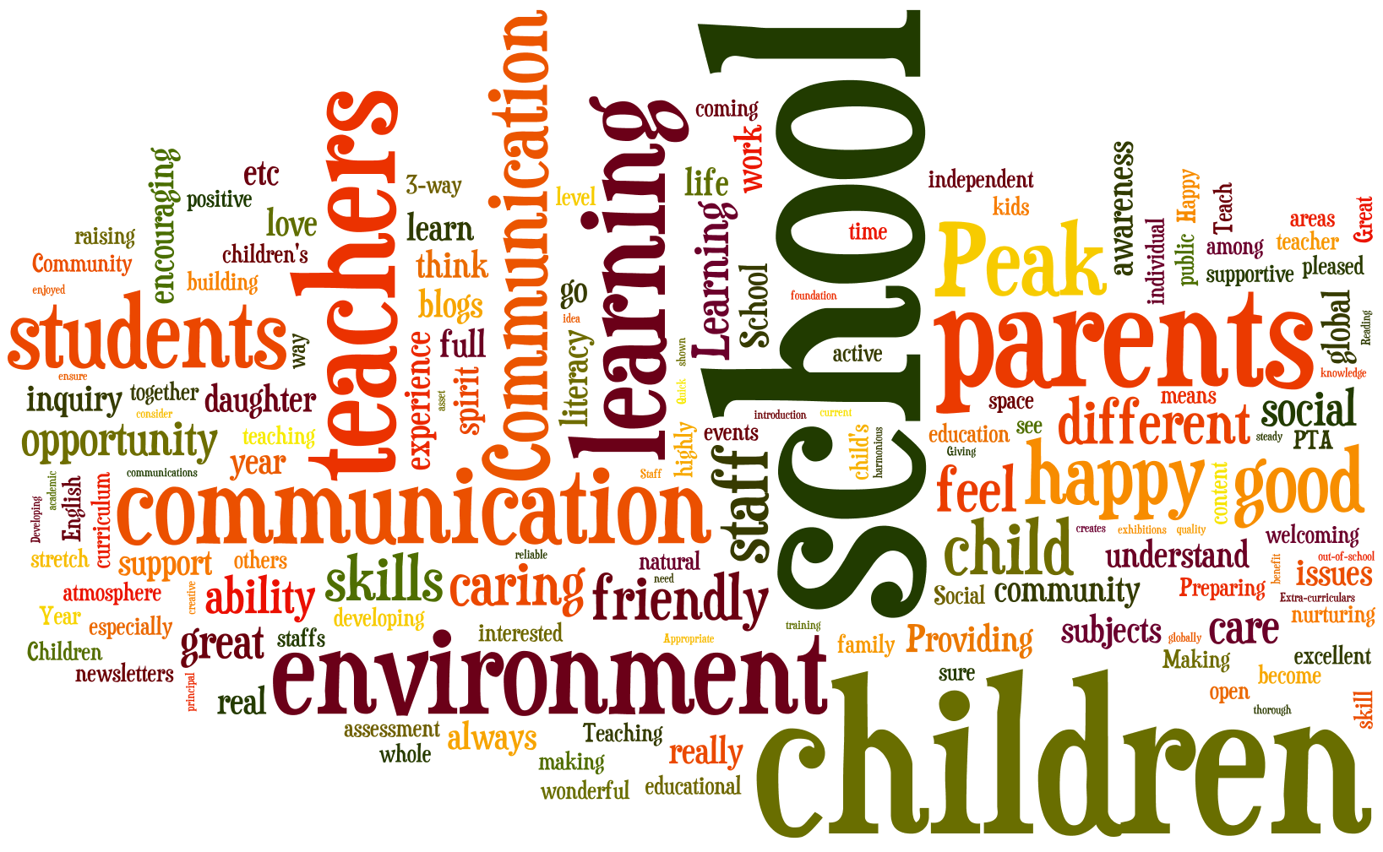

EVEN BETTER IF (summary of repeated comments)?

- Progress against standards or outcomes (coming shortly for Maths and English)

- Communication from school regarding expectations particularly for Maths and English (coming – new reporting standards)

- Knowing what content is being covered in class - very good in Year 1 and 2 with weekly newsletters (new 6 weekly UOI overview being sent out by all year groups)

- Would appreciate more time with the teacher during consultations (which are very good in general) – (parent consultation in Term 2 with just teacher and parent)

- More information about UOIs being taught so we understand what is being covered (workshops, POI posted on website and new 6 weekly overview sent out by all classrooms, display in foyer)

