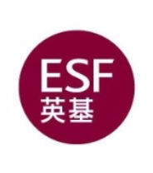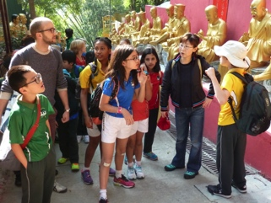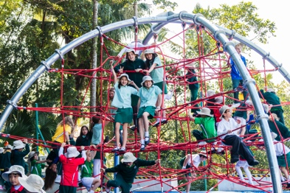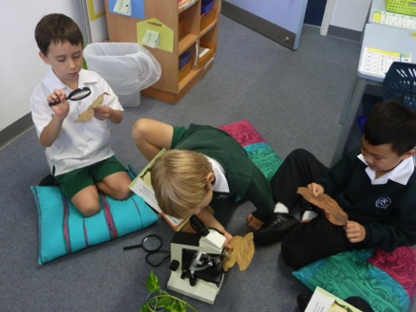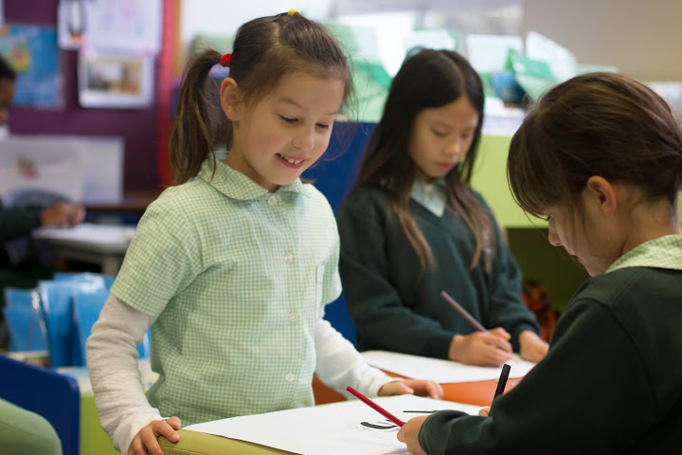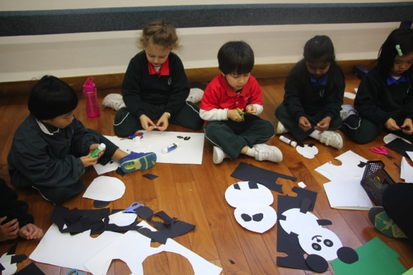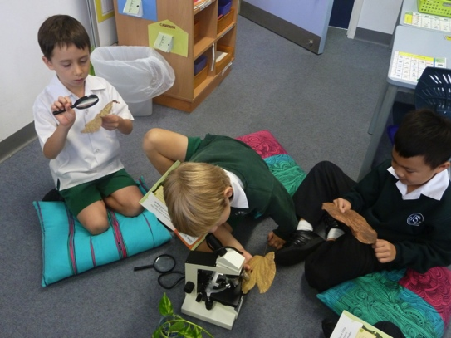

#### Restorative Practice

All parties i.e. students, staff (teaching and non teaching) and parents must accept they have a role to play in the development and maintenance of these relationships. The quality of these relationships will be reflected in the outcomes for students.

All staff are responsible for managing behaviour for all students.  Students must understand that **all** staff (EAs, support staff and teachers) have the right to question them about any behaviour/actions that are inappropriate.

# Everyone has a role to play

‘We use Restorative Practice to restore relationships at Peak School with the intention of resolving issues through a no blame approach’

At Peak School, the quality of relationships across our school community is a strong determinant of our overall success. We pride ourselves on being a community school and building and retaining trust is crucial to our success.

The interrelationships between students, staff (teaching and non teaching) and parents must be open, honest and respectful and have the achievement of the student and the well-being of all parties at their core.

## Introduction

Peak School

Effective March 2015

Can we talk?

School Community approach to managing relationships.

We will encourage this through the use of a consistent line of questioning, which may differ slightly for primary and secondary students (in language only):

**To the wrong doer**  
We’re here to talk about…  
What happened?  
What were you thinking at the time?

**When stuck**  
Was it the right or wrong thing to do?  
Was it fair or unfair?  
What exactly are you sorry for?  
You didn’t answer my question.

**To the victim**  
What did you think when it happened?  
What have you thought about since?  
How has it affected you?  
What’s been the worst of it?  
What’s needed to make things right?  
How can we make sure this doesn’t happen again?

Continued…

What have you thought about since? Who do you think has been affected by what you did?  
In what way?  
What do you need to do to make things right?  
How can we make sure this doesn’t happen again? What can I do to help you?

## Consistent line of questioning across the school…

### We use Restorative Practice to restore relationships at Peak School with the Intention of resolving through a no blame approach.

**Restorative Practice means that for any situation requiring intervention of staff and/or student mediators we are working to ensure that all parties:**

* Acknowledge their role in the incident
* Take responsibility for their actions
* Understand the impact of their actions
* Be part of the solution (where possible)

# Restorative Practice Procedures



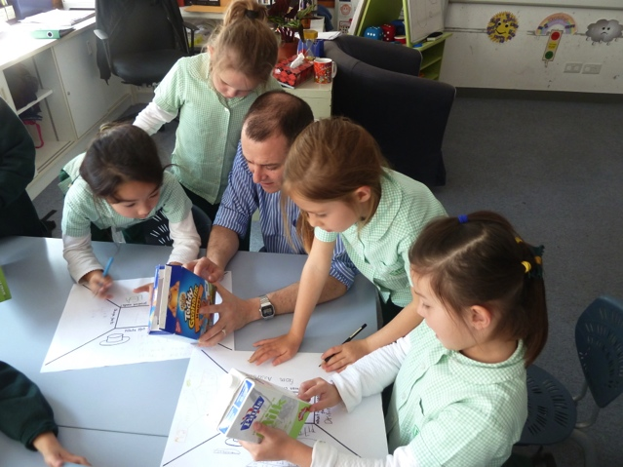

Restorative Practice does not preclude the use of other consequences that may be, but are not restricted to:

|  |  |
| --- | --- |
| Verbal warnings Meetings with teaching staff Exclusion from participation in events Referral to appropriate support agencies Reflections – during / after school  Appointment with St John Counsellor | Loss of privileges Verbal and/or written apologies Students sent home early Parent meetings Parents informed Exclusion from school |

Created March, 2015,

Review Date March, 2018

**Bullying**

* Bullying is the abuse of a relationship.
* Bullying is a type of behaviour that needs to be changed.
* Bullying is ongoing, unwanted behaviour on the part of the victim.

It can take a variety of forms - verbal, physical and cyber, therefore, Restorative Practice is appropriate in that we seek the same outcomes as for other behaviour management, through a similar line of questioning.